Module Assembly - TopCoder NodeJS Active Billing Accounts API Deployment Guide

Revision History
Author | Revision Number | Date
muzehyun | 1.0 | 2014/02/27

Deployment Instructions 3
1. Organization of Submission 3
2. Application Setup 3
2.1. Preconditions 3
2.2. Build Script Setup 3
3. Configurations 5
4. Deployment Instructions 6
5. Verification by tests 7
6. Resource Contact List 8

Deployment Instructions

Organization of Submission
Name | Description
tc-api/ | Main application source code of this assembly.  Contains only new and changed files.
Module Assembly - TopCoder NodeJS Active Billing Accounts API v1.0.doc | This file.

Application Setup

Preconditions
- Linux 64bit System (preferably the Ubuntu 10.04), which is used by Heroku stack for Nodejs), with development tool, such as g++, maker.
- Java (used to connect remote Informix Server)
- NodeJS 0.10.21 http://nodejs.org/
- Node-java https://github.com/joeferner/node-java
- Git
- Heroku Account and Toolbelt
  - Signup a Heroku account in https://api.heroku.com/signup/devcenter with your email address.
  - Download the Heroku Toolbelt from https://toolbelt.heroku.com, and make sure the Heroku CLI is working in your environment by typing the “heroku help”.
  - Login your Heroku account by typing the “heroku login”.
This requires you to input your email and password, and then finally it will upload your public SSH key to the server so that you don’t have to provide your credential during the subsequent commands.
If you have a “Permission denied (publickey)” error during deployment, you can use “heroku keys:add” to add the public key to the remote repo as described here.
- Installation Guide - https://github.com/cloudspokes/tc-api/wiki

Build Script Setup
Two BASH scripts are used to ease the deployment.
- deploy/development.sh
It helps to launch the application locally.
It simply exports the configured environment variables.
- deploy/heroku.sh
It helps to deploy the application onto the Heroku cloud.
It has command line switches.
Switch | Description
clean | It cleans the current repository information by simply removing the .git folder.
commit | It initializes the local repository and commits all the current project files, if the current directory is not a GIT repo yet; or commit all the changes to the local repository, if the current directory is already a GIT repo.
create | It creates a Heroku app for the current logged-in Heroku account.  This app will only be used if it is created when the current local GIT repo has not yet setup the remote repo of name “heroku”.  If your local repo has already setup “heroku” remote for an existing app, this app will not be picked as the target app for other Heroku commands. If you want to create an new Heroku app and use it as the target app in this case, you can clean and re-initialize the current local repo first, or you explicitly rebase it to the new Heroku app.
config | It exports all the configured environment variables to the target Heroku app.
push | It pushes the current committed version to the “heroku” remote.
launch | It launches one Heroku dyno to run the target app.
all | It will execute all other steps in the order: “clean”, “commit”, “create”, “config”, “push”, and then “launch”.
deploy | It only executes the steps to deploy the projects to the Heroku cloud: “config”, “push”, and then “launch”.  It assumes the code has been committed to the local repo, and the local repo has setup the “heroku” remote for the target app.

Configurations
There are two BASH scripts used to ease the deployments and launching of the application.
The configurations are defined in these scripts to export the environment variables.
One of them is for local development “tcapi/deploy/development.sh”, where configurations are defined from
Please replace VM_IP with your VM IP
Heroku.sh doesn’t contain configuration no more.

VM_IP=50.17.156.219

Deployment Instructions

- Setup heroku in section 2.1 and database in section 2.3.
- Run git clone https://github.com/cloudspokes/tc-api tc-api
- Run cd tc-api
- Run git checkout d89adb599d62c25df68cc0cbe8bbbd9d3f546698
- Copy all files from submission/tc-api to checked out tc-api and override all files
- Replace TC_VM_IP in section 3.
- In checked out tc-api run:
  - chmod +x deploy/heroku.sh
  - npm install
  - . deploy/heroku.sh all
  - After running the script, you can use “git remote -v” to see the “heroku” remote repo. The remote repo will be like git@heroku.com:<app-name>.git, you can know the create app name here.
- To deploy application in local environment run:
  - chmod +x deploy/development.sh
  - npm install
  - . deploy/development.sh
  - npm start
  - Server is listening on port 8080.
  - If you can’t stop application then run “. kill.sh”
  - If you get some error then try to rebuild node modules by running npm rebuild. If you have still problems then please see https://github.com/joeferner/node-java in “Installation Linux/Windows notes”. Make sure you have installed java.

Verification by tests
  - Js lint
Install the node-jslint in your local environment globally by “sudo npm install jslint -g".
Run following command under the <submission>/tc-api directory.

jslint -nomen actions/reports.js
jslint -nomen test/test.reportsGetActiveBillingAccounts.js

  - Mocha
Deploy application to localhost. See 4.8.
Run following commands under the <base>/tc-api directory.
(Run again “. deploy/development.sh” if you get invalid port error)
node_modules/.bin/mocha test/test.reportsGetActiveBillingAccounts.js

or deploy to heroku (See 4.7) and run on heroku
API_ENDPOINT= http://<app-name>.herokuapp.com node_modules/.bin/mocha test/test.reportsGetActiveBillingAccounts.js

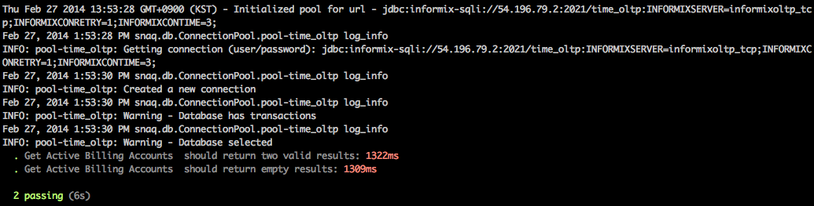

Resource Contact List
Name | Resource Email
muzehyun

